CROSSWORD
“The World of Flowers”
 |  |  |  |  |  |  | ² |  |  |  |  |  |  | ¹
 |  |  |  |  |  |  | l |  |  |  | ¹ | c | a | с | t | u | s
 |  |  |  |  |  |  | i |  |  |  |  |  |  | h
 |  |  |  |  | ³ | ² | l | a | v | e | n | d | e | r
 |  |  |  |  | f |  | a |  | ⁴ |  |  |  |  | y |  |  |  |  |  | ⁵
 |  |  |  |  | u |  | c |  | b |  |  |  |  | s | ³ | t | u | l | i | p
 |  |  |  |  | c |  |  |  | o |  |  |  |  | a |  |  |  |  |  | o
⁴ | d | e | l | p | h | i | n | i | u | m |  | ⁵ | s | n | o | w | d | r | o | p
 |  |  |  |  | s |  |  |  | g |  |  |  |  | t |  |  |  |  |  | p
 |  |  |  |  | i | ⁶ | h | y | a | c | i | n | t | h |  |  |  |  |  | y
 |  |  |  |  | a |  |  |  | i |  |  |  |  | e |  |  |  |  |  |  | ⁶
 |  |  |  |  |  |  |  |  | n |  |  |  |  | m |  |  |  |  |  |  | i |  |  |  | ⁸
 |  |  |  | ⁹ |  |  |  |  | v |  |  | ⁷ | s | u | n | f | l | o | w | e | r |  | ⁷ |  | h
 |  |  |  | c |  |  |  |  | i |  |  |  |  | m |  |  |  |  |  |  | i |  | c |  | i
 |  | ⁸ | g | l | a | d | i | o | l | u | s |  |  |  |  | ⁹ | c | o | c | k | s | c | o | m | b
 |  |  |  | o |  |  |  |  | l |  |  |  |  | ¹² |  |  |  | ¹³ |  |  |  |  | r |  | i
 |  |  |  | v |  | ¹⁰ | ¹⁰ | b | e | g | o | n | i | a | ¹¹ | v | i | o | l | e | t |  | n |  | s
 |  |  |  | e |  | p |  |  | a |  |  |  |  | s |  |  |  | r |  | ¹⁴ |  |  | f |  | c
 |  |  |  | r |  | e |  | ¹¹ |  |  | ¹² | b | u | t | t | e | r | c | u | p |  |  | l |  | u
 |  |  |  |  |  | o |  | d |  |  |  | ¹⁶ |  | e |  |  |  | h |  | a |  |  | o |  | s
 | ¹³ | p | e | t | u | n | i | a |  |  | ¹⁴ | c | a | r | n | a | t | i | o | n |  |  | w
 |  |  |  |  |  | y |  | n |  |  |  | r |  |  | ¹⁷ |  |  | d |  | s |  |  | e
 |  |  |  |  |  |  | ¹⁵ | d | a | f | f | o | d | i | l |  |  | ¹⁸ |  | y |  |  | r
 |  |  |  |  | ¹⁵ |  |  | e |  |  |  | c |  |  | i |  |  | l
 |  |  |  | ¹⁶ | d | a | h | l | i | a |  | u |  | ¹⁷ | l | o | t | u | s
 |  |  |  |  | a |  |  | i |  |  |  | s |  |  | y |  |  | p
 |  |  |  |  | i |  |  | o |  |  |  |  |  |  |  |  |  | i
 |  | ¹⁸ | j | a | s | m | i | n | e |  |  |  | ¹⁹ | g | e | r | a | n | i | u | m
 |  |  |  |  | y

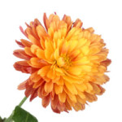
down:
1. a plant of the daisy family with brightly coloured ornamental flowers, existing in many cultivated varieties.

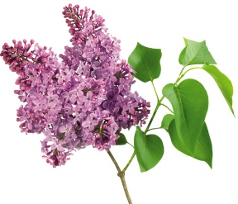
2. a Eurasian shrub or small tree of the olive family, which has fragrant violet, pink, or white blossom and is a popular garden ornamental.

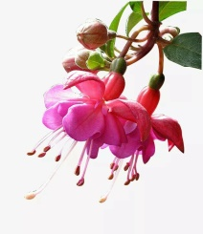
3. a shrub with pendulous tubular flowers that are typically of two contrasting colours. They are native to America and New Zealand and are commonly grown as ornamentals.

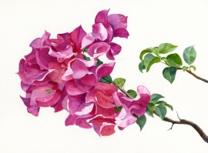
4. an ornamental shrubby climbing plant that is widely cultivated in the tropics. The insignificant flowers are surrounded by large, brightly coloured papery bracts which persist on the plant for a long time.
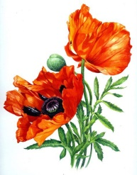
5. a herbaceous plant with showy flowers, milky sap, and rounded seed capsules. Many poppies contain alkaloids and are a source of drugs such as morphine and codeine.
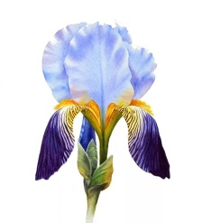

6. a plant with showy flowers, typically of purple or yellow, and sword-shaped leaves. Irises are native to both Eurasia and North America and widely cultivated as ornamentals.

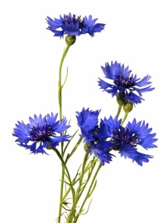
7. a slender Eurasian plant related to the knapweeds, with flowers that are typically a deep, vivid blue

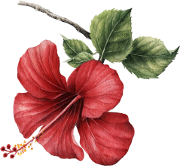
8. a plant of the mallow family, grown in warm climates for its large brightly coloured flowers or for products such as fibre or timber

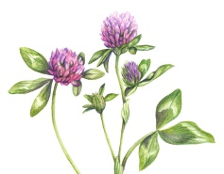
9. a herbaceous plant of the pea family, with dense globular flower heads and leaves which are typically three-lobed. It is an important fodder and rotational crop

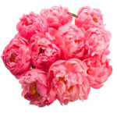
10. a herbaceous or shrubby plant of north temperate regions, which has long been cultivated for its showy flowers

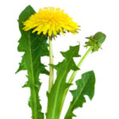
11. a widely distributed weed of the daisy family, with a rosette of leaves and large bright yellow flowers followed by globular heads of seeds with downy tufts

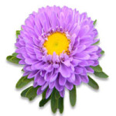
12. a plant of a large genus that includes the Michaelmas daisy, typically having purple or pink rayed flowers

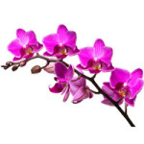
13. a plant with complex flowers that are often showy or bizarrely shaped, having a large specialized lip (labellum) and frequently a spur. Orchids occur worldwide, especially as epiphytes in tropical forests, and are valuable hothouse plants
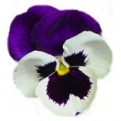
14. a cultivated variety of viola with brightly coloured flowers

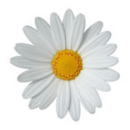
15. a small European grassland plant which has flowers with a yellow disc and white rays

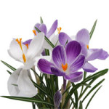
16. a small spring-flowering Eurasian plant of the iris family, which grows from a corm and bears bright yellow, purple, or white flowers

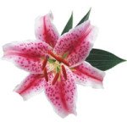
17. a bulbous plant with large trumpet-shaped, typically fragrant, flowers on a tall, slender stem

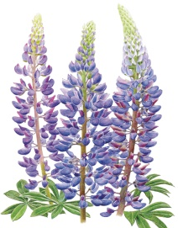
18. a plant of the pea family with deeply divided leaves and tall colourful tapering spikes of flowers

across:
1. a succulent plant with a thick fleshy stem which typically bears spines, lacks leaves, and has brilliantly coloured flowers.

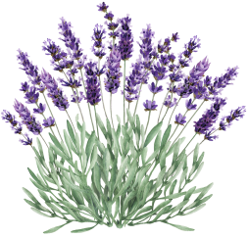
2. a small aromatic evergreen shrub of the mint family, with narrow leaves and bluish-purple flowers, used in perfumery and medicine

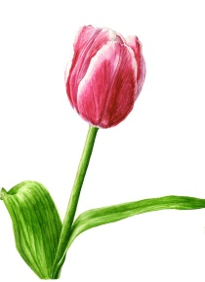
3. a bulbous spring-flowering plant of the lily family, with boldly coloured cup-shaped flowers

4. a popular garden plant of the buttercup family, which bears tall spikes of blue flowers

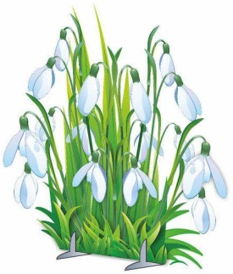
5. a bulbous European plant which bears drooping white flowers during the late winter

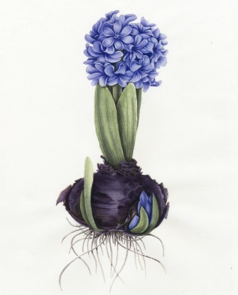
6. a bulbous plant of the lily family, with strap-like leaves and a compact spike of bell-shaped fragrant flowers. Native to western Asia, hyacinths are cultivated outdoors and as houseplants

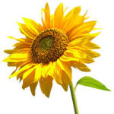
7. a bulbous plant of the lily family, with strap-like leaves and a compact spike of bell-shaped fragrant flowers. Native to western Asia, hyacinths are cultivated outdoors and as houseplants

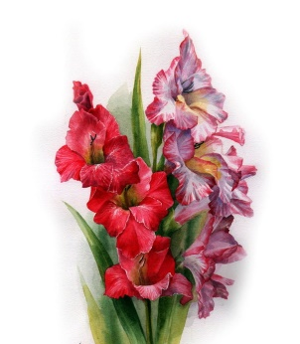
8. an Old World plant of the iris family, with sword-shaped leaves and spikes of brightly coloured flowers, popular in gardens and as a cut flower

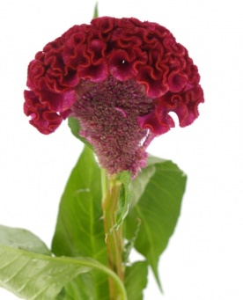
9. (also coxcomb) a tropical plant with a crest of tiny yellow, orange, or red flowers, grown as a pot plant

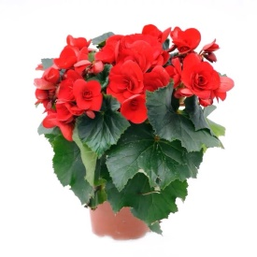
10. a herbaceous plant of warm climates, the flowers of which have brightly coloured sepals but no petals. Numerous cultivars are grown for their flowers or striking foliage

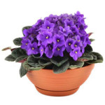
11. a herbaceous plant of temperate regions, typically having purple, blue, or white five-petalled flowers, one petal of which forms a landing pad for pollinating insects

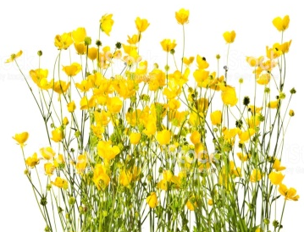
12. a herbaceous plant with bright yellow cup-shaped flowers, which is common in grassland and as a garden weed. All kinds are poisonous and generally avoided by livestock

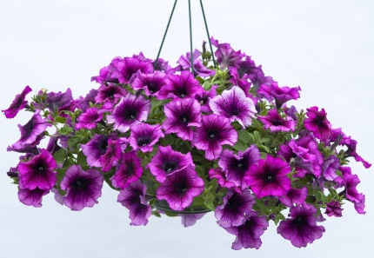
13. a South American plant of the nightshade family which has white, purple, or red funnel-shaped flowers, with many ornamental varieties

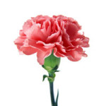
14. a double-flowered cultivated variety of clove pink, with grey-green leaves and showy pink, white, or red flowers

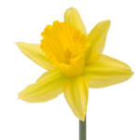
15. a bulbous European plant which typically bears bright yellow flowers with a long trumpet-shaped centre (corona)

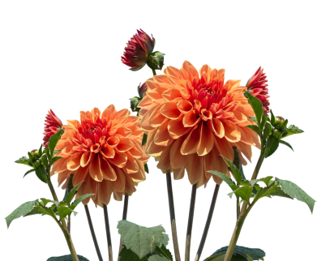
16. a tuberous-rooted Mexican plant of the daisy family, which is cultivated for its brightly coloured single or double flowers

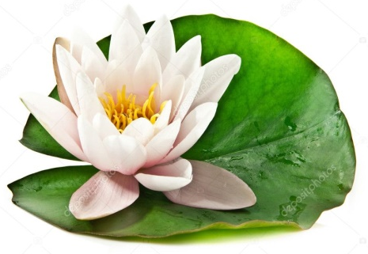
17. either of two large water lilies

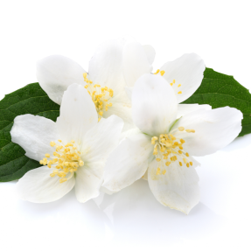
18. an Old World shrub or climbing plant which is popular as an ornamental and bears fragrant white, pink, or yellow flowers

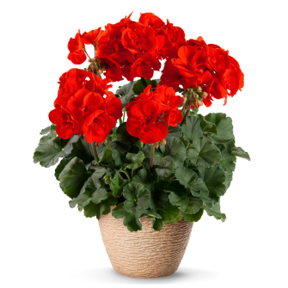
19. a herbaceous plant or small shrub of a genus that comprises the cranesbills and their relatives. Geraniums bear a long, narrow fruit that is said to be shaped like the bill of a crane

