Работа с графикой на языке Assembler.
Задание:
1)

2)
3) При щелчке ПКМ запоминается цвет объекта по которому щелкнули, при щелчке ЛКМ этот цвет применяется к объекту

Задание 1.
Модель:
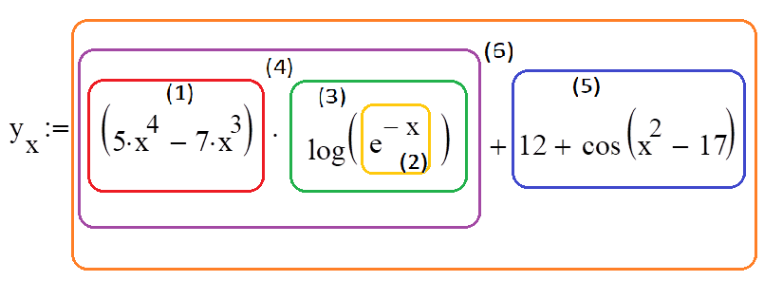
Код:
;-----------
choise_color db "Выберите цвет графика:",0
pen_color dd 00000000h
button_color dw ?
color_button_black db "Черный",0
color_button_blue db "Голубой",0
color_button_green db "Зеленый",0
color_button_red db "Красный",0
color_button_yellow db "Желтый",0
color_button_gray db "Серый",0
;-----------
;
color_button_id1 equ 2
color_button_id2 equ 3
color_button_id3 equ 4
color_button_id4 equ 5
color_button_id5 equ 6
color_button_id6 equ 7
Black equ 0000000h
Blue equ 0FF0000h
Green equ 000FF00h
Red equ 00000FFh
Yellow equ 000FFFFh
Gray equ 0080808h
;
;------------------------{
invoke CreateWindowEx,WS_EX_LEFT, ADDR STATIC,ADDR choise_color,\
WS_CHILD or WS_VISIBLE,\
220,5,200,25,hWnd,NULL,hInstance,NULL
invoke CreateWindowEx,NULL, ADDR ButtonClassName,ADDR color_button_black,\
WS_CHILD or WS_VISIBLE or BS_DEFPUSHBUTTON,\
220,35,100,25,hWnd,color_button_id1,hInstance,NULL
invoke CreateWindowEx,NULL, ADDR ButtonClassName,ADDR color_button_blue,\
WS_CHILD or WS_VISIBLE or BS_DEFPUSHBUTTON,\
220,65,100,25,hWnd,color_button_id2,hInstance,NULL
invoke CreateWindowEx,NULL, ADDR ButtonClassName,ADDR color_button_green,\
WS_CHILD or WS_VISIBLE or BS_DEFPUSHBUTTON,\
220,95,100,25,hWnd,color_button_id3,hInstance,NULL
invoke CreateWindowEx,NULL, ADDR ButtonClassName,ADDR color_button_red,\
WS_CHILD or WS_VISIBLE or BS_DEFPUSHBUTTON,\
330,35,100,25,hWnd,color_button_id4,hInstance,NULL
invoke CreateWindowEx,NULL, ADDR ButtonClassName,ADDR color_button_yellow,\
WS_CHILD or WS_VISIBLE or BS_DEFPUSHBUTTON,\
330,65,100,25,hWnd,color_button_id5,hInstance,NULL
invoke CreateWindowEx,NULL, ADDR ButtonClassName,ADDR color_button_gray,\
WS_CHILD or WS_VISIBLE or BS_DEFPUSHBUTTON,\
330,95,100,25,hWnd,color_button_id6,hInstance,NULL
;------------------------}
.ELSEIF uMsg==WM_COMMAND
mov eax,wParam
.IF ax==LINE_RB
mov flg,0
.ELSEIF ax==POINT_RB
mov flg,1
.ELSE
.IF ax==ButtonID
shr eax,16
.IF ax==BN_CLICKED
invoke GetWindowText,hwndEditMinX,ADDR buffer,25
invoke StrToInt, ADDR buffer
mov minX,eax
invoke GetWindowText,hwndEditMaxX, ADDR buffer,25
invoke StrToInt, ADDR buffer
mov maxX,eax
invoke GetWindowText,hwndEditStep,ADDR buffer,25
invoke StrToFloat, ADDR buffer, ADDR step
;Создаем доп. окно
invoke CreateWindowEx,WS_EX_CLIENTEDGE,ADDR ClassName1,ADDR AppNam1e,\
WS_OVERLAPPEDWINDOW,CW_USEDEFAULT,\
CW_USEDEFAULT,800,600,0,NULL,\
hInstance,NULL
mov hwnd1,eax

invoke ShowWindow, hwnd1, SW_SHOWNORMAL
invoke UpdateWindow, hwnd1
.ENDIF
.ENDIF
;---------{
.IF ax==color_button_id1
shr eax,16
.IF ax==BN_CLICKED
mov pen_color,Black
.ENDIF
.ENDIF
.IF ax==color_button_id2
shr eax,16
.IF ax==BN_CLICKED
mov pen_color,Blue
.ENDIF
.ENDIF
.IF ax==color_button_id3
shr eax,16
.IF ax==BN_CLICKED
mov pen_color,Green
.ENDIF
.ENDIF
.IF ax==color_button_id4
shr eax,16
.IF ax==BN_CLICKED
mov pen_color,Red
.ENDIF
.ENDIF
.IF ax==color_button_id5
shr eax,16
.IF ax==BN_CLICKED
mov pen_color,Yellow
.ENDIF
.ENDIF
.IF ax==color_button_id6
shr eax,16
.IF ax==BN_CLICKED
mov pen_color,Gray
.ENDIF
.ENDIF
;---------}

.ENDIF
.ELSE
invoke DefWindowProc,hWnd,uMsg,wParam,lParam
ret
.ENDIF
xor eax,eax
ret
WndProc endp

count proc
;(первая скобка) (1)
mov [tmp], 5
fld x
fmul x
fmul x
fmul x
fimul tmp
mov [tmp], 7
fld x
fmul x
fmul x
fimul tmp
fsubp
;e^-x
fld x
fchs
fldl2e
fmul
fld st
frndint
fsub st(1), st
fxch st(1)
f2xm1
fld1
fadd
fscale
fstp st(1)
;log(e^-x) (2)
fldlg2
fxch
fyl2x
;(1)*(2) (3)
fmulp
;12+cos(x^2-17) (4)
fld x
fmul x
mov [tmp], 17
fisub tmp
fcos
mov [tmp], 12
fiadd tmp
;(3) * (4)
faddp
;Считаем X и Y, как координату пикселя
fmul ScaleY
fild OffsetY
fsubr
fistp intY
fld x
fmul ScaleX
fiadd OffsetX
fistp intX
ret
count endp

@enddd:
end start

Демонстрация:
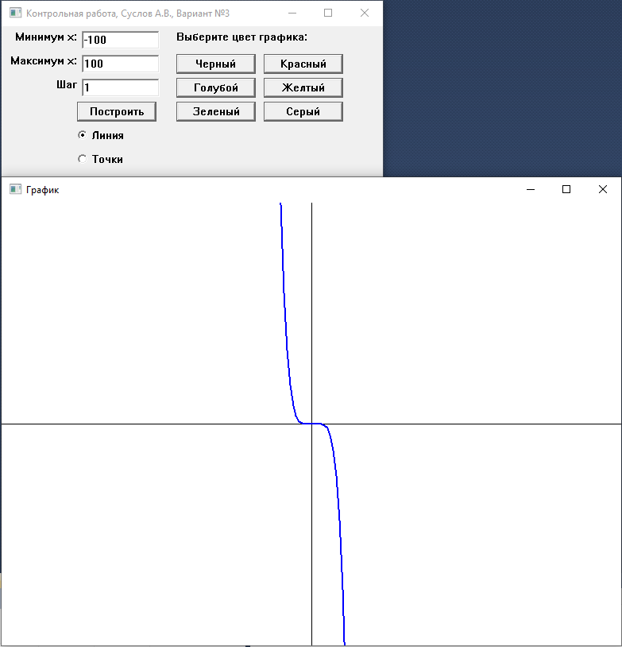

Задание 2,3
Модель:
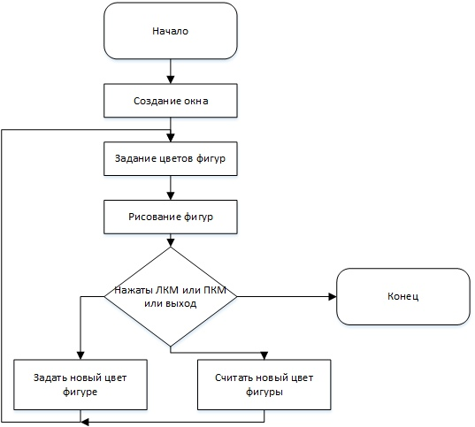
Код:
WndProc proc hWnd:HWND, uMsg:UINT, wParam:WPARAM, lParam:LPARAM
LOCAL hOld:HDC
LOCAL hMemDC: HDC
LOCAL hBmp: HDC
LOCAL ps:PAINTSTRUCT
LOCAL rc:RECT
LOCAL hdc:HDC

.IF uMsg==WM_DESTROY
invoke PostQuitMessage, NULL
ret
.ELSEIF uMsg==WM_CREATE
;1 треугольник
mov polygon1.x, 150
mov polygon1.y, 150
mov polygon1[type POINT].x, 350
mov polygon1[type POINT].y, 150
mov polygon1[2*type POINT].x, 350
mov polygon1[2*type POINT].y, 50

;второй треугольник
mov polygon2.x, 150
mov polygon2.y, 350
mov polygon2[type POINT].x, 350
mov polygon2[type POINT].y, 350
mov polygon2[2*type POINT].x, 350
mov polygon2[2*type POINT].y, 450

.ELSEIF uMsg==WM_PAINT
invoke GetClientRect, hWnd, ADDR rc
invoke BeginPaint, hWnd, ADDR ps
mov hdc, eax
;Контекст устройства в памяти
invoke CreateCompatibleDC, hdc
mov hMemDC, eax
;Bitmap для рисования
invoke CreateCompatibleBitmap, hdc, rc.right, rc.bottom
mov hBmp, eax
;Присоединяем bitmap к DC
invoke SelectObject, hMemDC, hBmp
mov hOld, eax
;Заливка рабочей области окна
invoke FillRect, hMemDC, ADDR rc, 0
;board
invoke SelectObject, hMemDC, color_taken
invoke Rectangle, hMemDC, 5, 5, 20, 20
invoke SelectObject, hMemDC, color_board
invoke Rectangle, hMemDC, 25, 25, 680, 670

;Рисуем фигуры
invoke SelectObject, hMemDC, color_border
invoke SelectObject, hMemDC, color_rectangle_3
invoke Rectangle, hMemDC, 400, 300, 600, 480
invoke SelectObject, hMemDC, color_first_triangle
invoke Polygon, hMemDC, ADDR polygon1, 3
invoke SelectObject, hMemDC, color_second_triangle
invoke Polygon, hMemDC, ADDR polygon2, 3
invoke SelectObject, hMemDC, color_rectangle
invoke Rectangle, hMemDC, 50, 150, 150, 350
invoke SelectObject, hMemDC, color_quadr
invoke Rectangle, hMemDC, 150, 150, 350, 350
invoke SelectObject, hMemDC, color_circle
invoke Ellipse, hMemDC, 250, 150, 450, 350
invoke SelectObject, hMemDC, color_circle_2
invoke Ellipse, hMemDC, 350, 150, 650, 450
invoke SelectObject, hMemDC, color_rectangle_2
invoke Rectangle, hMemDC, 500, 60, 575, 350
invoke SelectObject, hMemDC, color_circle_3
invoke Ellipse, hMemDC, 300, 400, 500, 650
invoke SelectObject, hMemDC, color_rectangle_4
invoke Rectangle, hMemDC, 60, 500, 620, 650
;Рисуем палитру
invoke SelectObject, hMemDC, color_palitra_1
invoke Rectangle, hMemDC, 700, 50, 750, 100
invoke SelectObject, hMemDC, color_palitra_2
invoke Rectangle, hMemDC, 700, 110, 750, 160
invoke SelectObject, hMemDC, color_palitra_3
invoke Rectangle, hMemDC, 700, 170, 750, 220
invoke SelectObject, hMemDC, color_palitra_4
invoke Rectangle, hMemDC, 700, 230, 750, 280
invoke SelectObject, hMemDC, color_palitra_5
invoke Rectangle, hMemDC, 700, 290, 750, 340
invoke SelectObject, hMemDC, color_palitra_6
invoke Rectangle, hMemDC, 700, 350, 750, 400
invoke SelectObject, hMemDC, color_palitra_7
invoke Rectangle, hMemDC, 700, 410, 750, 460
invoke SelectObject, hMemDC, color_palitra_8
invoke Rectangle, hMemDC, 700, 470, 750, 520
invoke SelectObject, hMemDC, color_palitra_9
invoke Rectangle, hMemDC, 700, 530, 750, 580
invoke SelectObject, hMemDC, color_palitra_10
invoke Rectangle, hMemDC, 700, 590, 750, 640
;

;Двойная буферизация
invoke BitBlt, hdc, 0, 0, rc.right, rc.bottom, hMemDC, 0, 0, SRCCOPY
invoke SelectObject, hMemDC, hOld
invoke DeleteObject, hBmp
invoke DeleteDC, hMemDC
invoke EndPaint, hdc, ADDR ps
;-----------------------
.ELSEIF uMsg==WM_RBUTTONDOWN
mov eax,lParam
mov posx,ax
shr eax,16
mov posy,ax
.IF wParam==MK_RBUTTON ;левая кнопка мыши
.IF posx>150 ;quadr
.IF posx<350
.IF posy>150
.IF posy<350
mov eax,[color_quadr]
mov [color_taken],eax
mov posx,0
.ENDIF
.ENDIF
.ENDIF
.ENDIF
;|||||||||||||||||||||||||||||||||||||||||||||||||||||||||||||||||||||||||||||||||||||||||||||||||||||
.ELSEIF uMsg==WM_LBUTTONDOWN ;правая кнопка мыши
mov eax,lParam
mov posx,ax
shr eax,16
mov posy,ax
.IF wParam==MK_LBUTTON
.IF posx>150 ;quadr
.IF posx<350
.IF posy>150
.IF posy<350
mov eax,[color_taken]
mov [color_quadr],eax
mov posx,0
.ENDIF
.ENDIF
.ENDIF
.ENDIF
invoke InvalidateRect, hWnd, 0, FALSE
.ENDIF

.ELSE
invoke DefWindowProc, hWnd, uMsg, wParam, lParam
ret
.ENDIF
xor eax, eax
ret
WndProc endp

Демонстрация:
